Pesalink Testing Steps:

- Go to the gateway: https://10.11.6.111:8443/admin/docs
- Enter valid Credential:
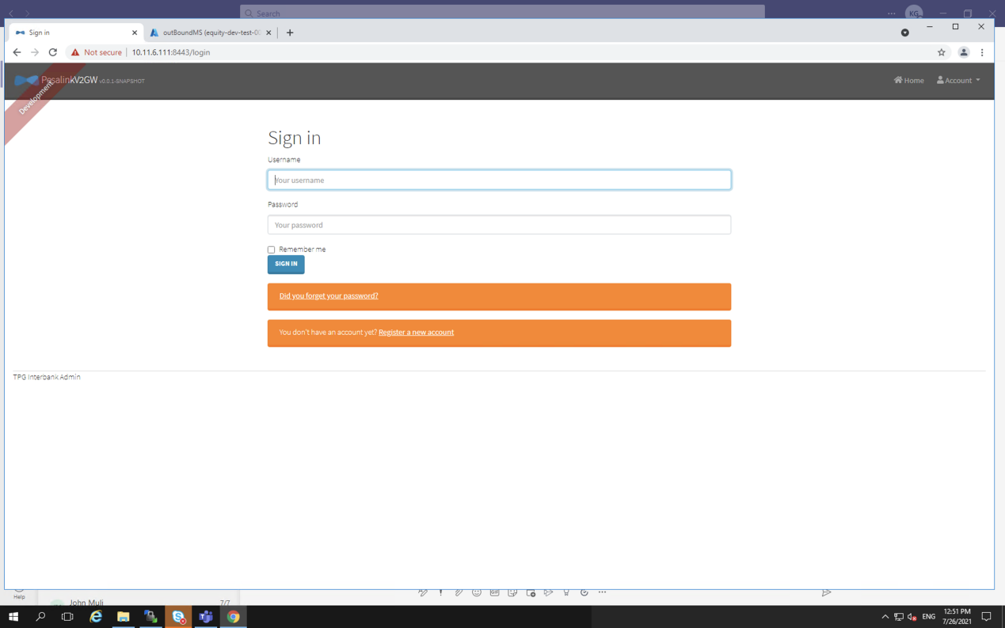

- On Administration tab, select API
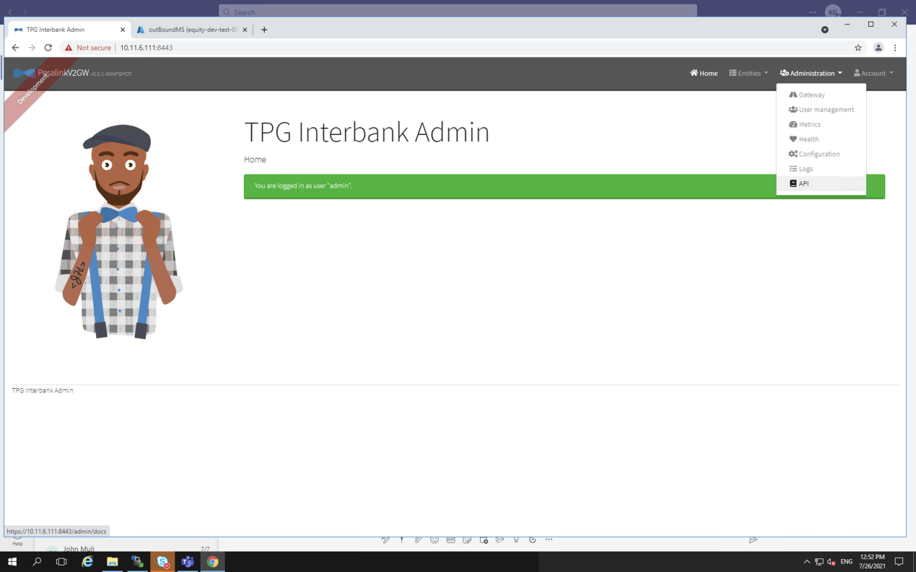

- select pesalinkbusinessms
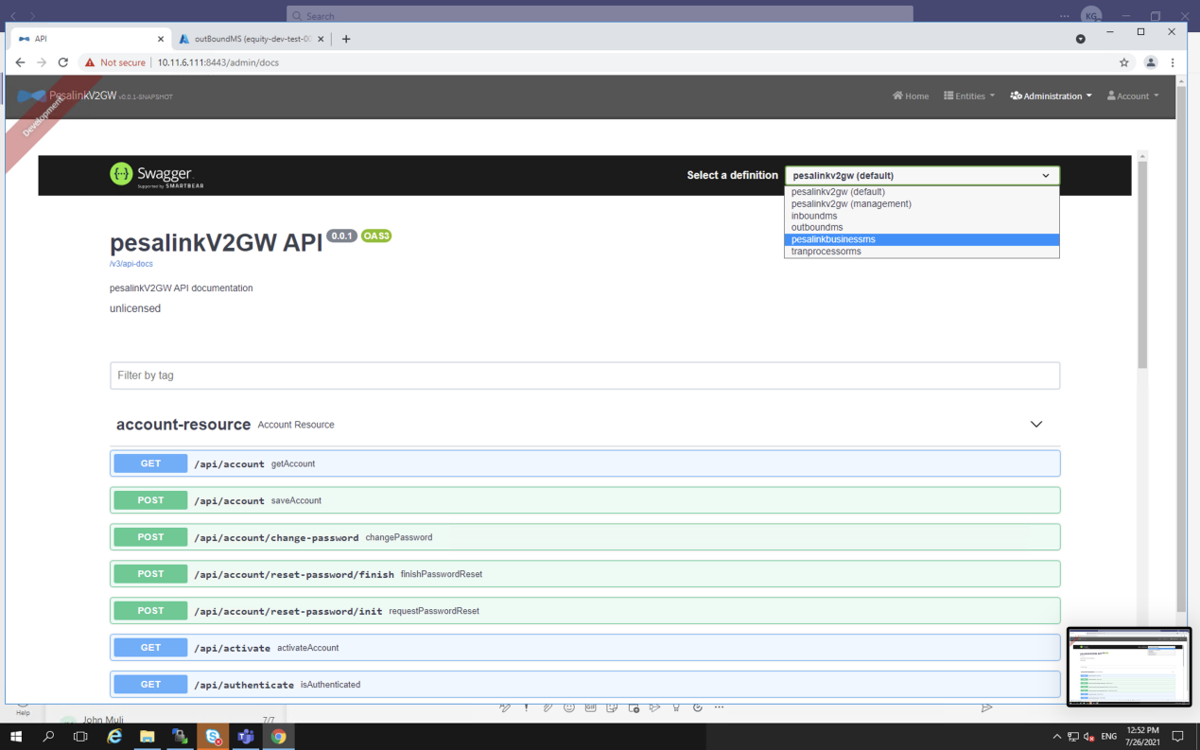

- For the purpose of this particular testing, work with business-service-resource
